Lead-in Activities
- List the uses of gold as many as possible and discuss the roles of gold in modern society with your partners.
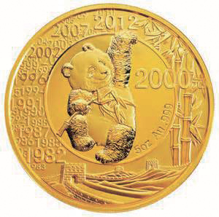

- Do you know the reverse images of the following current Chinese bank notes? Figure out the reasons why these images have been used and discuss them with your partners.

Text Comprehension
1. Read the core text quickly, work in pairs and answer the following questions.
(1) What was the earliest form of Chinese money? How would you account for the adoption of this form of money?
(2) How many shapes of bronzed money are mentioned in the text? What are they?
(3) What is the name of the earliest paper money in the world? When did it first appear?
(4) What do the ingots resemble? Where can we see them nowadays?
(5) How did Chinese banking start?
(6) Based on this text and your personal experience, what do you think is the development tendency of money in the future?
(7) What else do people in your hometown do on Tomb Sweeping Day in addition to what has been mentioned in the text?

2. After you have read the whole text, draw a brief map of the development of money in China with arrows or any shapes you like in the following box.

